Create a React App “counterapp” which will have a component named “CountPeople” which will have 2 methods.

**Directory:**

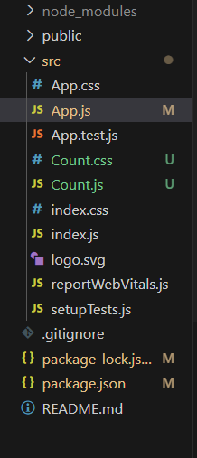

**Code for Count.js:**

import React, { useState } from 'react';

import './Count.css';

const Count = () => {

  const [login, setLogin] = useState(0);

  const [exit, setExit] = useState(0);

  const handleLogin = () => {

    setLogin(login + 1);

  };

  const handleExit = () => {

    setExit(exit + 1);

  };

  return (

    <div className="count-container">

      <div className="action-box">

        <button className="btn" onClick={handleLogin}>Login</button>

        <span className="message">{login} People Entered!!!</span>

      </div>

      <div className="action-box">

        <button className="btn" onClick={handleExit}>Exit</button>

        <span className="message">{exit} People Left!!!</span>

      </div>

    </div>

  );

};

export default Count;

**Code for count.css:**

.count-container {

  display: flex;

  justify-content: center;

  align-items: center;

  margin-top: 100px;

  gap: 100px;

}

.action-box {

  display: flex;

  align-items: center;

  gap: 10px;

}

.btn {

  background-color: #4CAF50;

  color: white;

  font-weight: bold;

  padding: 8px 16px;

  border: 1px solid green;

  border-radius: 5px;

  cursor: pointer;

}

.btn:hover {

  background-color: #45a049;

}

.message {

  color: green;

  font-weight: 500;

}

**Code for App.js:**

import React from 'react'

import Count from './Count'

const App = () => {

  return (

    <div>

    <Count />

    </div>  )

}

export default App

**Output:**

